Estimating Market Desirability for Armada Carriers: Predictive Modeling and Causal Inference
Aidan McIndoe, Michael Zheng, Yuhao Ren

1 Introduction
The overall objective of this project is to understand and quantify freight market desirability for the carriers using historical shipment data. To enable quantitative analysis, it is best to identify an indicative variable for market desirability. After examining an array of variables related to market preference (see Section 2), we determined that a carrier’s tender acceptance behavior, in aggregation, best reflects the attractiveness of the specified market. Since we only have the materialized loads in the project data, the best proxy for this purpose is the waterfall list position of the carrier carrying the load. Armada relies heavily on the primary carriers on its various shipment routes. If the primary carrier refuses to carry the load and the load goes to another carrier down the list, or onto the spot market, the load is considered less attractive to carriers. This is referred to as “primary acceptance”.

However, primary acceptance rates can be misleading, as they reflect not only market desirability but also differences in individual shipment characteristics, such as price, timing, and other operational factors. As a result, simple aggregation of primary acceptance by destination markets confounds market desirability effects with differences in shipment mix, making it difficult to isolate whether observed disparities truly reflect market-level conditions.

To account for these influences, the original research objective is further refined into two related but distinct research questions. First, in the predictive perspective, we ask: How can we accurately predict primary acceptance, and by extension carrier behavior, given load-specific information, including destination market? Answering this question is most useful for individual prediction tasks. Second, in the causal perspective, we ask: How does the destination market affect carriers’ behavior (primary acceptance) when controlling for these various load variables? This question reframes market desirability as a counterfactual quantity—what acceptance rates would look like if otherwise comparable shipments were sent to different markets.

To address these questions, we adopt a dual modeling strategy. We first develop a high-performance predictive model using gradient boosting to understand acceptance behavior in a predictive context. We then construct a causal model using only pre-treatment covariates and apply counterfactual simulation via standardization to estimate market-level acceptance probabilities under a common shipment distribution. Together, these two perspectives provide complementary insight into freight market desirability, balancing predictive accuracy with causal interpretability.

2 Data & EDA
Armada provided data on 460,951 shipments from March 2024 - February 2025, with 47 different fields (variables). They can be organized into the following categories:

Category | Description
Carrier ID & Class | Carrier ID, Carrier Class, Carrier waterfall position, etc.
Origin & Destination | Zip code, region, state, lane ID, etc.
Cargo Detail | Temperature requirement, weight, size, quantity, etc.
Timing | Lead time, pick-up/delivery due date, actual departure/arrival date, etc.
Pricing | Paid rate, spot rate, contract rate, N.A.P. price, etc.
Transit Detail | Number of stops, transit time, etc.

We first performed exploratory data analysis on the different variables in isolation. We did not find any single trend that is immediately informative on market desirability. (results can be found in Appendix A)
However, we did observe a few related variables. Next we examined three metrics which could provide insight when trying to quantify desirability. These were: frequency, inbound to outbound ratio, and pricing. The conclusion from examining them is that although they are not satisfactory as direct reflections of desirability, they are helpful to pipeline development later.

Lane Statistics

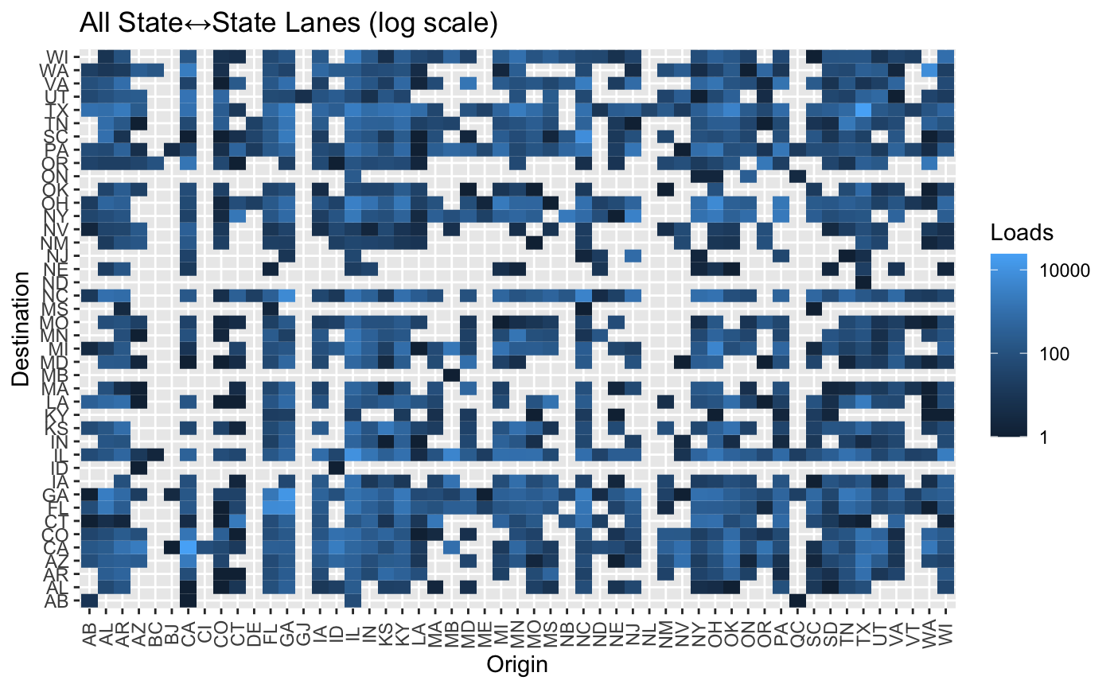
Figure 1: Frequency of lanes (state level)

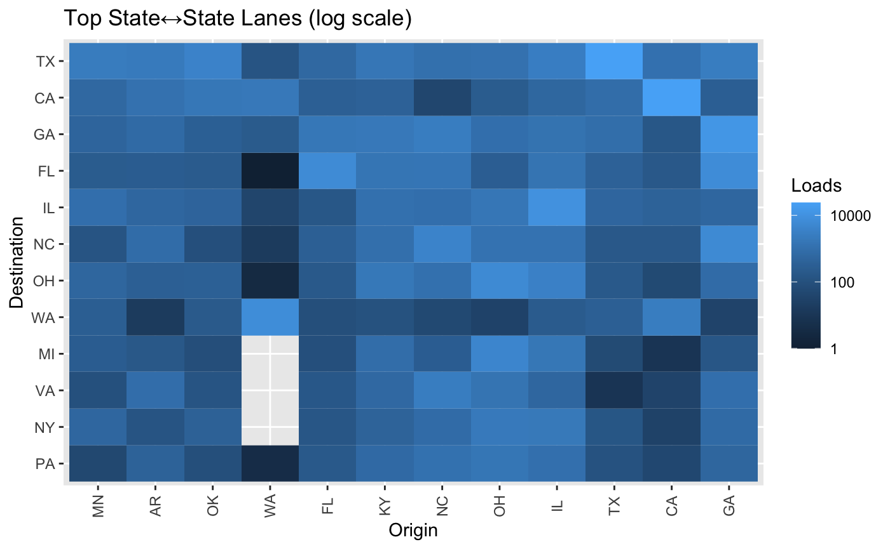
Figure 2: Most frequent State - State Routes
Figure 1 and Figure 2 highlight the most frequently visited state to state routes. This was not a good measure of desirability itself, as shipment routes/destinations are shaped by market demand and are not determined by carrier’s preference. Regardless, examining frequency greatly helped inform later model choices. As can be seen from Figure 1 and Figure 2, there is a difference of several magnitudes between the highest and lowest visited routes even on a logarithmic scale, suggesting that a closer look into the distribution of frequency was required.

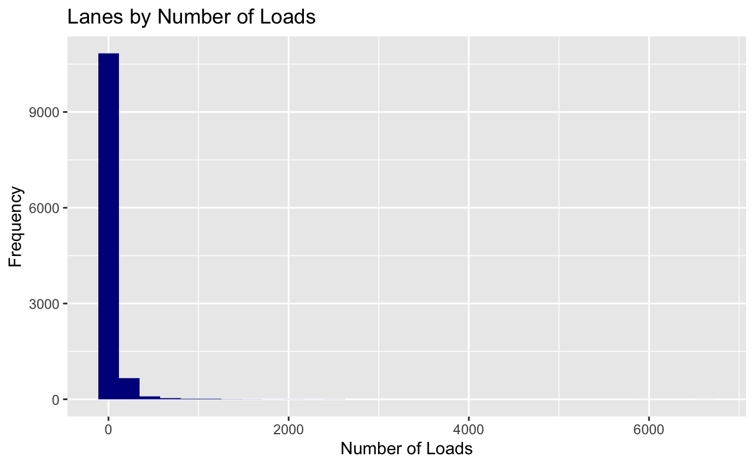
Figure 3: Distribution of Lane Usage

Figure 3 highlights the strong right skewness of the number of loads per lane. This strong right skewness, the large amount of categorical variables, combined with the variables’ high-cardinality (11,676 categories for lane ID alone), suggests that a non-linear model will be more appropriate for our analysis. More specifically, it helped infer that a tree-based model or a neural network may be an appropriate fit. The large right skewness of the lane usages were useful in helping determine which thresholds we should use for when applying either of these two families of models.

Inbound/Outbound
We could also examine whether a market was more likely to be a destination state or an origin state.
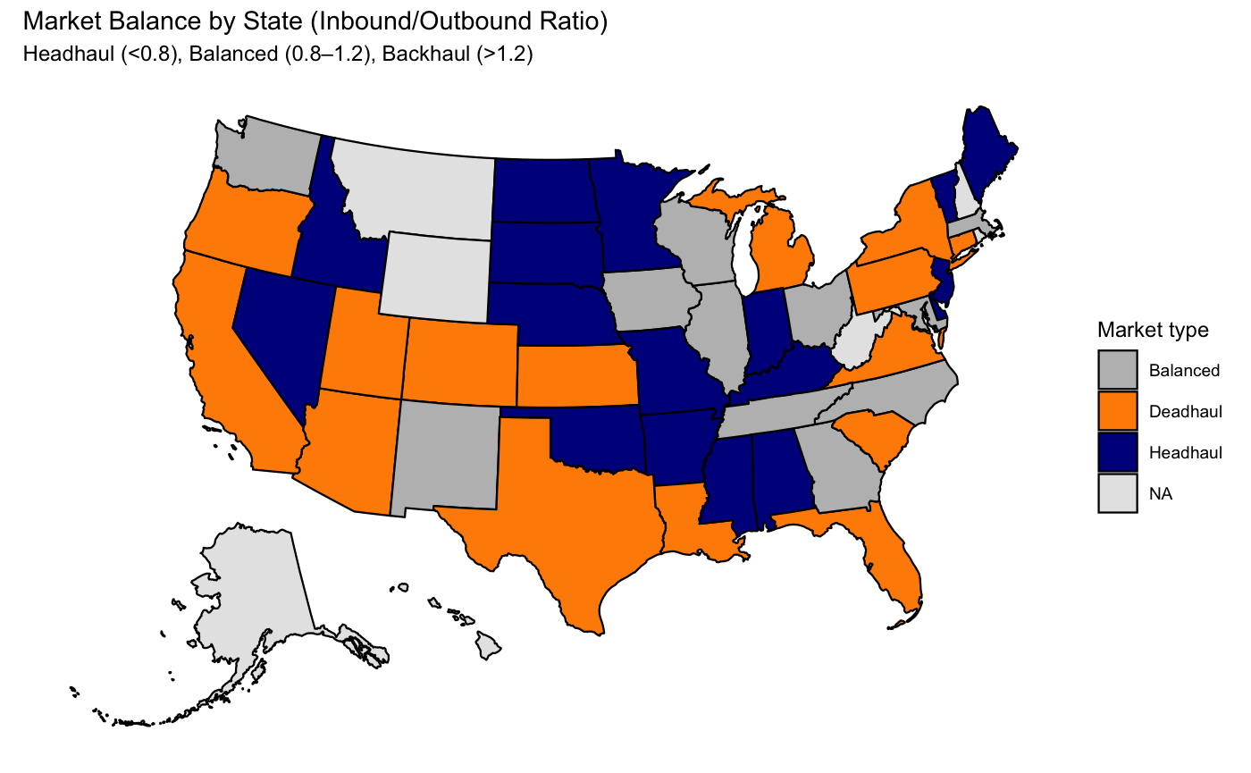
Figure 4: Inbound/Outbound Ratio by State

Figure 4 shows us the markets at a state level, and highlights which markets are headhaul or backhaul states, based on Armada’s loads. While informative, we found that it was not a good measure of desirability due to representativeness. The project dataset only includes loads for Armada, and we cannot extrapolate the true inbound/outbound ratio for the entire market. However, such information might still be useful, and this statistic is included in our later feature engineering process.

Price Premium
The next metric we examined was pricing. We wished to examine which markets were offering higher rates compared to others, to see if that may yield any insights into desirability.

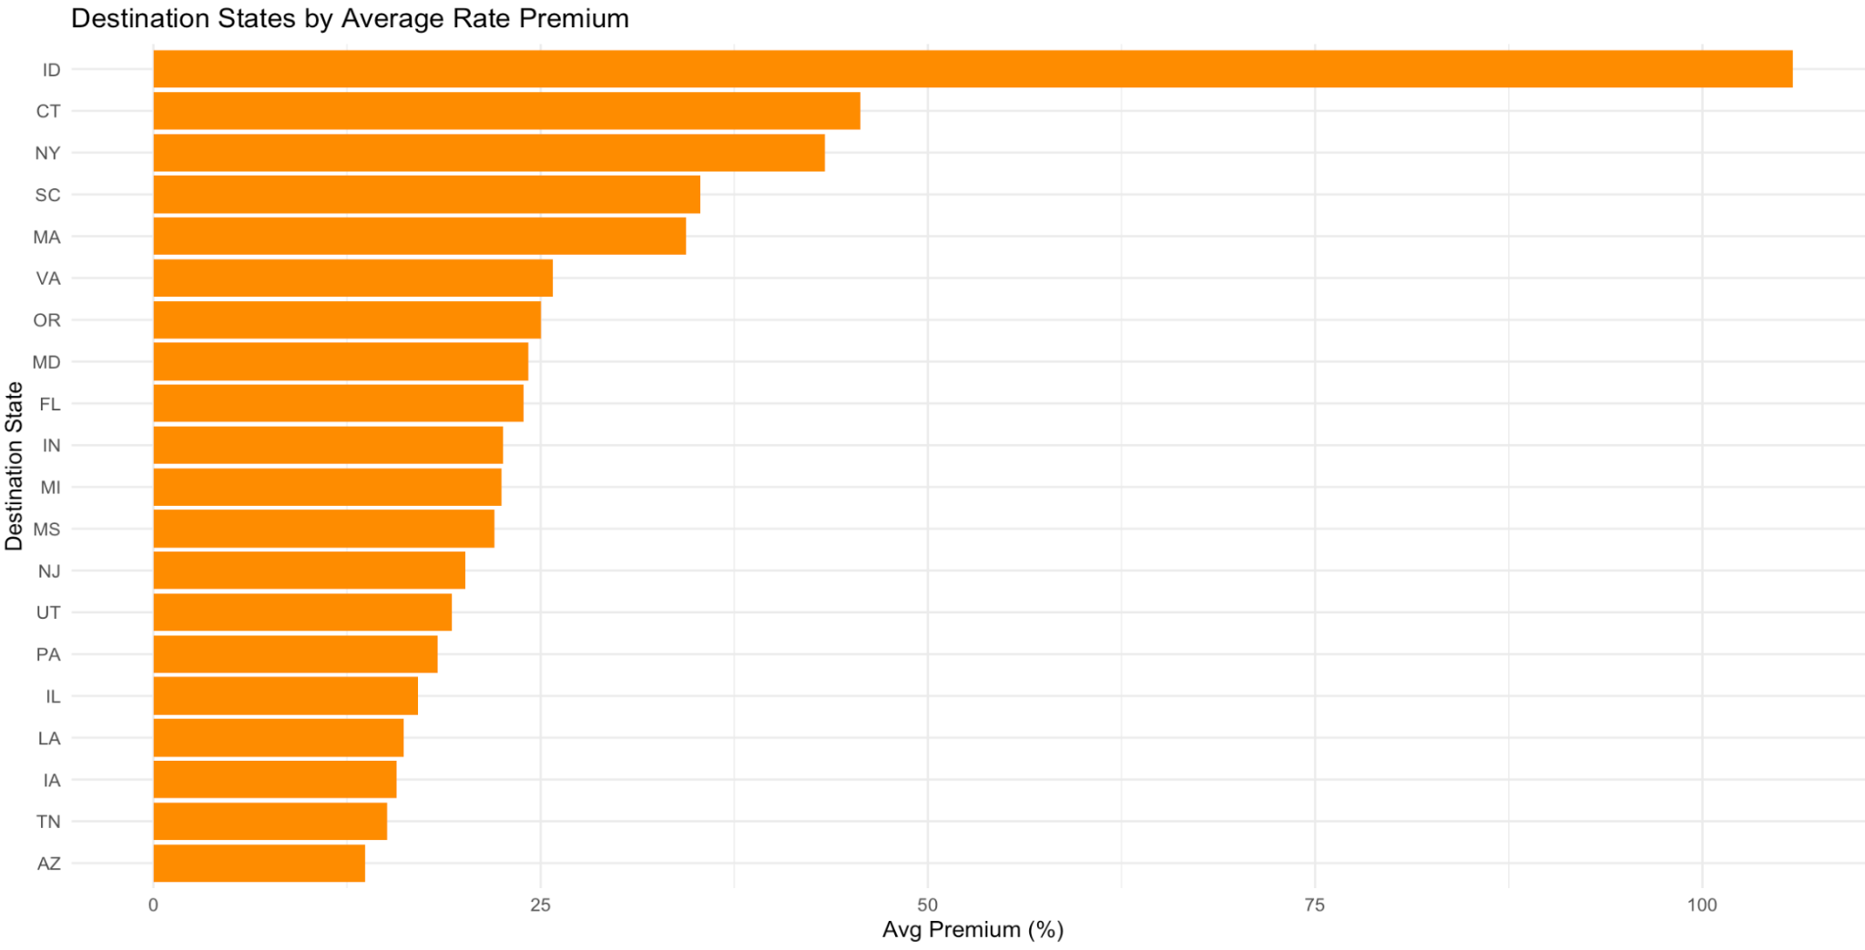
*Rate premium = (paid-NAP)/NAP x 100%
Figure 5: Destination States by Relative Price

Figure 5 shows the destination states that Armada offers the highest premiums relative to other states. It is worth noting that Idaho in particular appears to be offering significantly higher rates on average than the other states Armada services. While informative of general pricing, our team decided not to use pricing as a measure of desirability due to pricing being influenced by a significant number of other factors (mileage, lead time, etc.)

3 Methods

3.1 Objectives
From our initial investigation into the data, we were able to conclude three major points of action when modeling for carrier market-desirability:
- First, we need a direct indicator of carrier behavior from the data to be used as a reference for our analysis. This would allow effective validation of our pipeline, making sure it is rigorous.
- Second, we needed to select models which were able to account for the high-skewness and high-cardinality categorical variables in the data set.
- Finally, the models need to support the corresponding predictive and causal tasks, which are needed to account for the influence of variables other than market on desirability.

3.2 Measure of desirability
Recall the first objective for modeling, which is ease in validation. This leads to us needing a response variable to gauge our models. Our investigation into the data led us to consider tender acceptance as our response variable when constructing our models, which we ultimately used primary acceptance as its proxy. We found that primary acceptance is an appropriate measure of market desirability because it is directly reflective of carrier behavior, as a primary carrier rejecting a load more often indicates that a market is less desirable to carriers. Primary acceptance can be easily modeled with our dataset, as it can be extracted from the “Award Type” variable in our data.

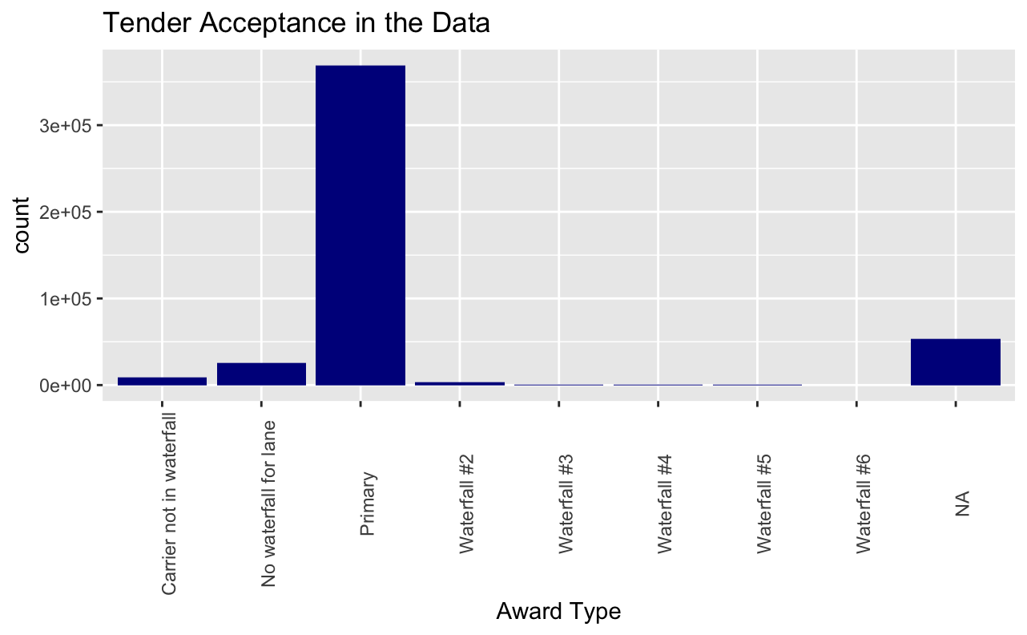
Figure 6: Distribution of Award Type in the dataset

From figure 6, we can see that the vast majority of primary carriers were receptive and no fallback occurred. Even though fallbacks were not as common, there were still thousands of them. This meant that we could create a strong model with the data provided without running into the risk of not having enough data to reasonably predict a category.

If a fallback occurred, it suggests that some aspect of the load assigned to them was undesirable to the primary carrier. This suggests we could use a system of binary classification to predict desirability, and sort loads by desirable and undesirable shipments. We chose to split loads between Primary and Non-Primary (a waterfall occurred) to construct our binary classifier.
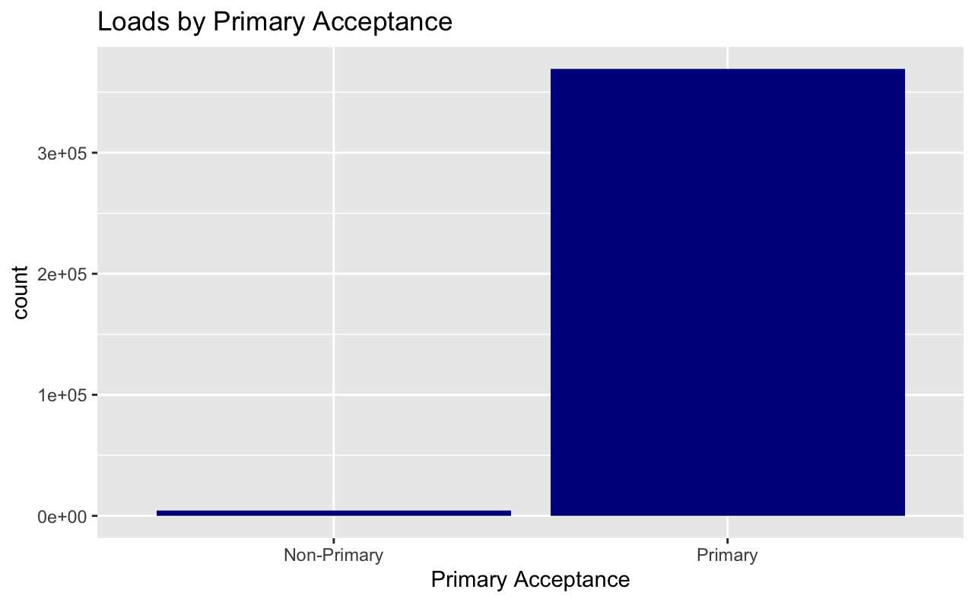
Figure 7: Binary Classification for Tender Acceptance
Figure 7 shows the binary classification of the data, with most loads being classified as Primary and the waterfall loads being classified as Non-Primary. While Primary loads still vastly outnumber Non-Primary loads, we have enough Non-Primary loads to construct a sufficient model. This classification allowed us to make initial comparisons between the characteristics of Primary and Non-Primary loads (see Appendix B) while also highlighting a few caveats we needed to account for when constructing the model itself.
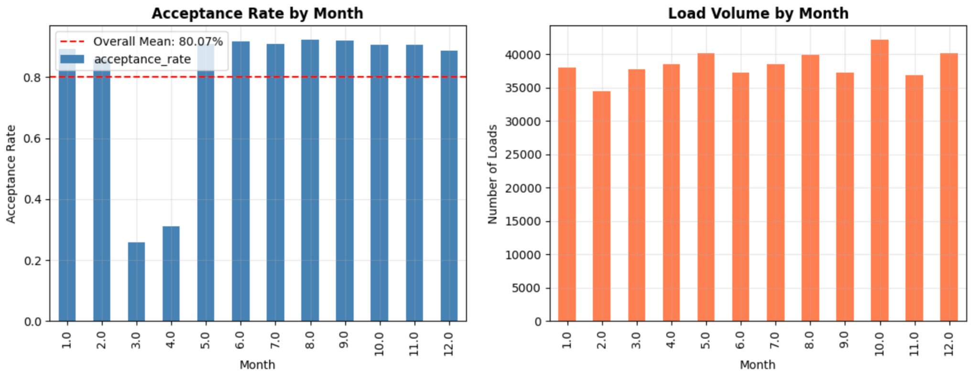
Figure 8: Primary Acceptance Rate by Month
Figure 8 highlights a significant decrease in the primary acceptance rate during March and April. Upon clarification from Armada, we learned that these months were when Armada made changes to carriers. As such, we did not include these months in the models as it was not representative of the general markets.
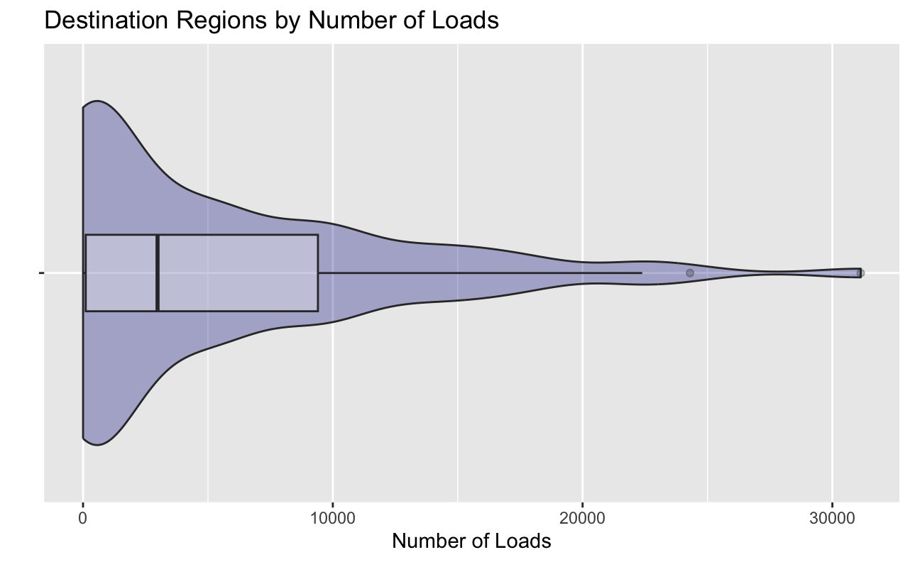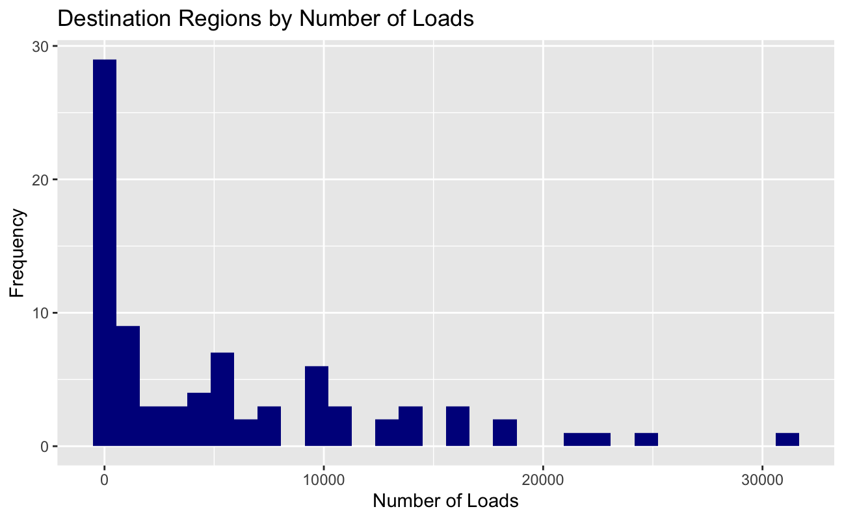
Figures 9 and 10: Distribution of Destination Regions

When making predictions on the markets themselves, we would need to adjust the threshold for the predictions. Figures 9 and 10 highlight that some regions were visited significantly more frequently than others and that some regions had a noticeably smaller number of loads delivered to them. As such, we would need to be careful what threshold we selected for predicting whether a load was Primary or Non-Primary.

3.3 Model Choice and Algorithm Overview

3.3.1 Model Overview

To answer both research questions (predictive & causal), we need two modeling pipelines.

Predictive Task

For the predictive task, we want to predict carrier behavior, given shipment details. These details include the destination market. This model is the most suited if Armada’s ultimate goal for “carrier desirability” is to see if an individual load is likely to be accepted by the primary carrier, or in general the desirability of that load to the carriers. This model is constructed for the sole purpose of producing correct classifications, therefore it includes all potentially useful load details in addition to destination market, and is optimized on binary classification performance only.

These characteristics determine that it is powerful in individual predictions. However, it also limits its extrapolative use such as aggregating predictions, which is neither statistically rigorous nor meaningful. This means the model is not suited to provide a more comprehensive, market-level insight that accounts for all the confounding influences of the shipment details.

As indicated below (Figure 11), the predictive pipeline consists solely of a predictive engine (learner), which takes preprocessed inputs from the data and outputs a predicted result (accepted vs denied).

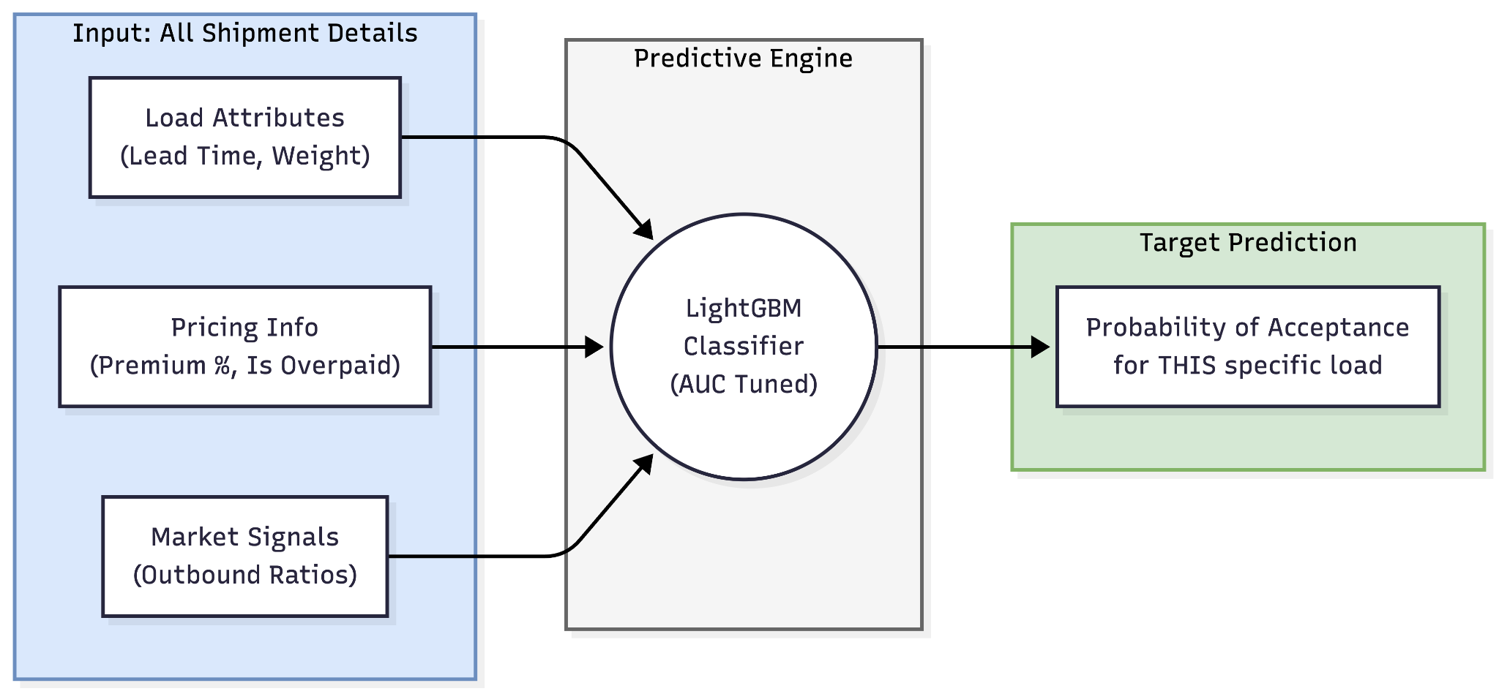
Figure 11: Predictive Model Pipeline Overview

Causal Analysis Task

For the causal analysis task, we want to “isolate” the effect of destination markets on load desirability to carriers. Specifically, we want to explore how loads, like the ones in our dataset, will fare differently if they are routed to different markets. In other words, we want to construct these hypothetical scenarios to make sure other load details (e.g. price, lead time) that individually affect load desirability do not confound the influence of the destination market. This model is the most suited if Armada’s goal is just to explore "market desirability” in itself as an influence factor alongside other load details, without immediately using it to predict results for individual loads.

Implementing counterfactual analysis involves several steps, indicated below (Figure 12). The implementation includes a predictive engine (learner) that learns carrier behavior, and a simulation step where the trained learner is fed simulated data and is asked to output predicted probabilities of primary acceptance. The simulation step is performed individually for each market of concern, and the resulting market desirability ranking is derived from aggregating simulated outputs for each destination market.

Notice that the learner in the causal pipeline shares the basic architecture with that in the predictive pipeline. However, since the goal of this pipeline is the construction of the hypothetical scenario (counterfactual analysis), the modeling emphasis is on faithfulness of the construction instead of the accuracy of individual predictions. Therefore this model takes in a different set of inputs, and is optimized differently.

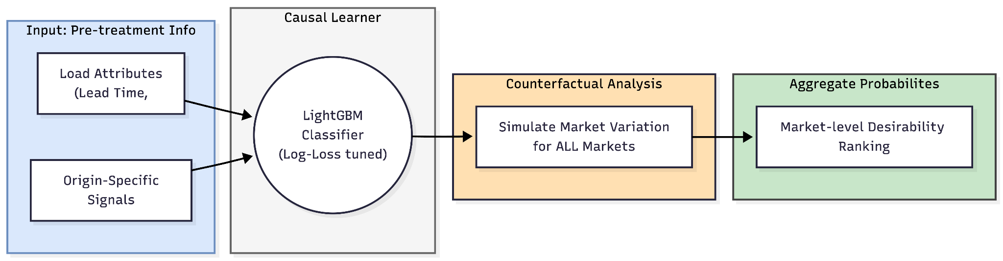
Figure 12: Causal Analysis Pipeline Overview

3.3.2 Learner Architecture

LightGBM(Light Gradient Boosting Machine) is an ensemble learning method that builds a strong classifier from many weak classifiers (decision trees). It operates sequentially: each new tree is trained to predict the errors (residuals) of the previous trees, thereby boosting the model's performance over time. At each step, it selects the leaf that most improves the objective (intuitively: the part of the tree where the model is performing worst) and splits it next. This strategy means the model is also more computationally efficient for large-scale datasets.

We selected LightGBM as our learner model for the following reasons:
- Scalability and Speed: It is explicitly optimized for large datasets, running faster than alternatives like XGBoost while maintaining high effectiveness. This was crucial given the volume of Armada's data.

- Handling Categorical Data: LightGBM has native support for categorical variables, which was essential given the "many variables and many categories" present in our lane and region data.

- Accuracy: The leaf-wise growth strategy allows the model to better fit the complex, non-linear boundaries of market desirability, focusing its complexity where the error is highest.

To provide a comprehensive analysis for Armada, we developed two different modeling strategies using the same architecture, but with different feature selection and training steps.

Predictive Task
This learner model focuses on accuracy at individual shipment level. It estimates the conditional probability

P(accept =1 | market = m, X)

where X represents ALL potentially related covariates, along with additional constructed features.

2. The Casual Inference Model: This model aims to derive the intrinsic factors of market desirability. It answers questions like: “How does a carrier’s acceptance behavior react to Market A, specifically?” By controlling for confounding variables (such as lead time), the model estimates a counterfactual probability: P(accept =1 | do(market = m))

The Casual Inference Model is preferred if Armada is interested in ranking the markets based on the true preference by carriers.

3.3.3 Feature Selection and Engineering
Our analysis used two different feature sets tailored to the specific goals of each model. While the Predictive Model sought to maximize forecast accuracy using all available information, the Causal Model required a rigorous selection process to isolate the specific impact of location on desirability.

Predictive Model
The goal of the predictive model is to estimate the probability of acceptance as accurately as possible given the information available at the moment a load is tendered. Therefore, our selection strategy focused on capturing market dynamics, pricing incentives, and historical behavior.
From the original dataset, we selected: 'lead_time_hours', 'distance', 'DESTINATION_REGION', 'ORIGIN_REGION', 'CARRIER_CLASS_CD', 'month', 'day_of_week', 'quarter'.

We engineered many features to capture the complex economics of freight logistics:

- Pricing Incentives (premium_pct, is_overpaid/underpaid): Pricing is a primary driver of carrier behavior. We calculated the premium_pct by comparing the paid rate to the market benchmark NAP. We also created categorical variables like is_overpaid (top 25% of premiums) to capture non-linear responses to high rates.

- Geographical features: We calculated inbound-to-outbound volume ratios for geographical location. A high "Outbound Ratio" indicates it is easy to find a reload, making the inbound trip more desirable. We engineered origin_outbound_ratio', 'destination_outbound_ratio', 'destination_region_outbound_ratio', 'destination_region_backhaul_difficulty', 'destination_region_is_freight_sink'. We also looked at the destination region’s load volume and historical acceptance.

- Interaction Terms: Desirability is rarely univariate. A low price might be acceptable for a short haul but rejected for a long haul. We engineered interaction terms to allow the model to learn these conditional relationships.

Future Recommendations for Armada: While our engineered features captured general market dynamics, Armada possesses more knowledge on the market side that can further refine this process. By reselecting variables, more feature engineering and more accurate threshold selection, the predictive model will be behaving better suited for Armada.

Causal Inference Model
The Causal Inference model requires a fundamentally different approach. Our goal here is not just to predict acceptance, but to measure the intrinsic desirability of a market. To do this, we must rigorously classify variables as confounders, mediators, or colliders.

Causal Concepts Overview
- Confounder: A variable that influences both the treatment (Market) and the outcome (Acceptance). If ignored, these create bias.
- Mediator: A variable that is caused by the treatment and then causes the outcome. These are the "mechanisms" of the effect.
- Collider: A variable that is caused by both the treatment and the outcome. Conditioning on these creates false associations.

Causal Selection Strategy: To better make inferences, we made specific choices that differ from the predictive model. Specifically, since in the counterfactual analysis (or simulation) we only allow controlling for the “confounder” class, we only trained on causal learner on the pre-treatment variables, and not on others.

3.3.4 Model Training and Optimization
Once our features were engineered and selected, the next phase is training the model to recognize patterns within Armada’s data. To achieve this, we implemented a training pipeline using Bayesian Optimization.

The Tuning Challenge
Every advanced machine learning algorithm, including the LightGBM we selected, is controlled by a set of external configurations known as "hyperparameters." These settings dictate how the model learns. For example, the learning_rate controls how quickly the model adapts to errors, num_leaves limits the complexity of the decision trees to prevent overfitting, and min_data_in_leaf ensures that statistical conclusions are based on a sufficient sample size.

Using the default settings for these parameters rarely yields optimal results. If the model is too complex, it will "overfit," memorizing noise in the training data and failing to predict new loads accurately. If it is too simple, it will "underfit," missing important market nuances. Finding the perfect balance is a complex search problem, as there are billions of possible combinations of these settings. Traditional methods, such as Grid Search (trying every combination) or Random Search (guessing blindly), are computationally inefficient and often miss the optimal configuration.

Implementing Bayesian Optimization
To solve this optimization challenge efficiently, we utilized Bayesian Optimization. Unlike random guessing, Bayesian Optimization is an intelligent search strategy that learns from its own past performance. It treats the hyperparameter search as a probability problem.

When the tuning process begins, the algorithm selects a set of parameters and evaluates the model's performance. Based on that result, it updates a probabilistic model that maps specific hyperparameter values to expected accuracy. With each iteration, it balances two goals: exploration (trying entirely new areas of the parameter space where uncertainty is high) and exploitation (refining values in areas known to perform well).

This approach allowed us to converge on the optimal model configuration significantly faster than traditional methods.

Robustness via Cross-Validation
To further ensure that our optimization results were reliable, we integrated K-Fold Cross-Validation directly into the tuning loop. Instead of training the model on one static portion of the data, the Cross-Validation process splits the dataset into five distinct "folds".

During each round of the Bayesian Optimization, the model was trained five separate times, each time holding out a different fold for validation. The performance metric used to guide the optimization was the average accuracy across all five folds. This validation technique prevents the model from becoming biased toward any specific month or region of data.

4 Results

4.1 Predictive Model

Model Performance
The primary objective of the predictive model was to accurately forecast whether a carrier would accept or reject a specific load based on market and load characteristics.

The model demonstrated exceptional predictive accuracy, achieving an Area Under the Curve (AUC) score of 0.9918. In data science, an AUC of 0.5 suggests random guessing, while 1.0 represents a perfect model. A score of 0.99 indicates that our model has successfully captured the vast majority of the signal driving carrier behavior.

When breaking this down into specific outcomes, the model achieved a Positive Prediction Accuracy of 99.15%. This means that when the model predicts a carrier will accept a load, it is almost always correct. Crucially, the model also maintained a strong Negative Prediction Accuracy of 91.55%. Predicting rejections is more difficult because they are rarer events as most tenders are accepted.
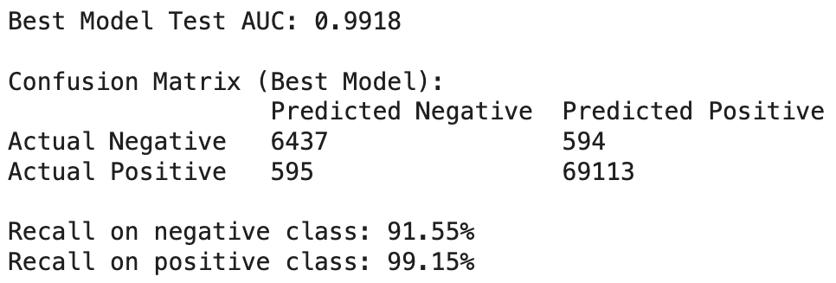
The confusion matrix above details these results. Out of nearly 70,000 positive instances in our validation set, the model missed only 595. Similarly, it correctly identified 6,437 rejections, misclassifying only 594. This balance suggests the model is not biased toward simply guessing "Accept" but is genuinely discriminating between desirable and undesirable freight.

However, we do not treat high accuracy as sufficient on its own. We also want more evidence on how the model predicts vs the actual scenario. The plot below aggregates outcomes by lane and compares actual lane-level acceptance rates to the model’s predicted lane-level acceptance rates.
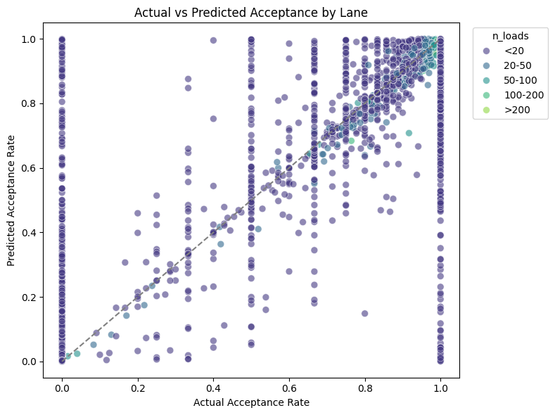
The key pattern is that the points cluster around the diagonal, especially for lanes with more observations (larger n_loads). This is exactly what we would expect from a robust model: with more historical volume, the lane’s acceptance behavior becomes easier to estimate, and the model’s predictions stabilize. At the same time, the scatter is wider for very small-volume lanes, which is what we brought up in our presentation that it is harder to predict for the smaller lanes.

Drivers of Carrier Behavior (Feature Importance)
Understanding why the model makes a prediction is just as important as the prediction itself. By analyzing the Feature Importance, which is a measure of how much a specific variable improves the model’s accuracy, we can identify the primary drivers of market desirability.
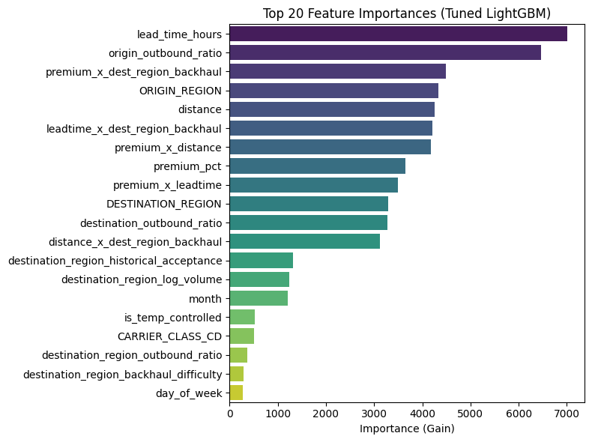
As illustrated in the chart above, the single most critical factor driving carrier acceptance is lead_time_hours. This aligns perfectly with logistical intuition: regardless of the market, carriers require sufficient notice to plan their capacity.

The second most important feature is origin_outbound_ratio. This variable acts as a proxy for the "Headhaul" vs. "Backhaul" status of a market. It confirms that carriers are significantly more likely to accept a load if it originates in a region where they can easily find a subsequent outbound load.

The interaction term premium_x_dest_region_backhaul ranks third. This is a sophisticated insight: it implies that money matters most when the destination is difficult. Carriers are willing to accept standard rates for desirable lanes, but they become highly price-sensitive when asked to drive into a "dead" market where they might get stuck.

A key caution for Armada: feature importance tells us what the model uses to predict, not what causes acceptance. So we interpret these as operational signals (what reliably correlates with acceptance behavior), not as a guarantee that changing one feature will always change outcomes by the same amount.

Market Desirability Rankings
By applying this trained model to our simulation dataset, we generated a desirability ranking for every market in the Armada network. Instead of looking at raw historical acceptance rates (which can be biased by one market having "easier" freight than another), these rankings represent the model's confidence.
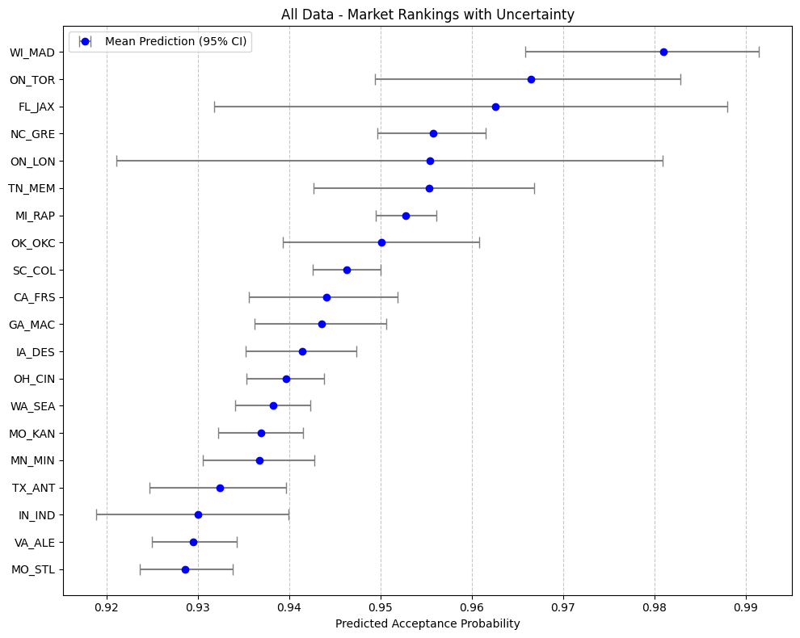
The simulation identified Madison, WI, Toronto, ON, and Jacksonville, FL as the top three most desirable markets in the network. The visualization also highlights the importance of data volume. The error bars (confidence intervals) surrounding each market's ranking indicate our certainty. Markets like Toronto (NC_GRE) show very tight intervals, meaning we are highly confident in their high ranking. Other markets may show wider intervals, suggesting that while they appear desirable, the behavior there is more volatile or the data is more sparse. When a higher ranked market has a larger confidence interval than lower ranked markets, we can’t generalize that the higher ranked market is essentially more preferable to carriers.

Interpreting the Rankings and Limitations
It is crucial to contextualize what these predictive rankings represent. The ranking generated by this model reflects the probability of acceptance for a specific shipment given the current variables. It answers the question: "In the current state of Armada’s network, where are we most likely to get a 'Yes' from a primary carrier?" This differs significantly from the Causal Model rankings discussed in the next section, which aim to isolate the intrinsic value of a market by stripping away the specific details of the load itself.

If the rankings produced by this predictive model differ from Armada’s internal expectations or industry intuition, the discrepancy is likely driven by two key data limitations inherent to this dataset:
- The Primary Acceptance Proxy: Our response variable is a proxy. We defined "desirability" based on whether the Primary Carrier accepted the load. However, the dataset only contains shipments that were eventually tendered. We lack data on tenders that were rejected and the negotiation that occurs before acceptance. Therefore, the model is optimizing for "Primary Carrier Preference" rather than absolute "Market Acceptance."

- Network Bias in Ratios: A key driver in our model is the outbound_ratio (the balance of trucks entering vs. leaving a region). Currently, this ratio is calculated solely based on Armada’s internal network volume. This creates a bias. A market might appear balanced in Armada’s data but be a massive headhaul market in the broader national freight network. Because the model learns from this biased view, its perception of market desirability is strictly relative to Armada’s existing footprint, not the entire US trucking market.

Despite these data-level limitations, the modeling pipeline itself remains a robust and valuable asset. As Armada integrates more comprehensive data sources, such as third-party market volume data to correct the outbound ratios, or true tender logs to correct the acceptance proxy, the model will automatically recalibrate and become better suited for Armada.

4.2 Causal Analysis

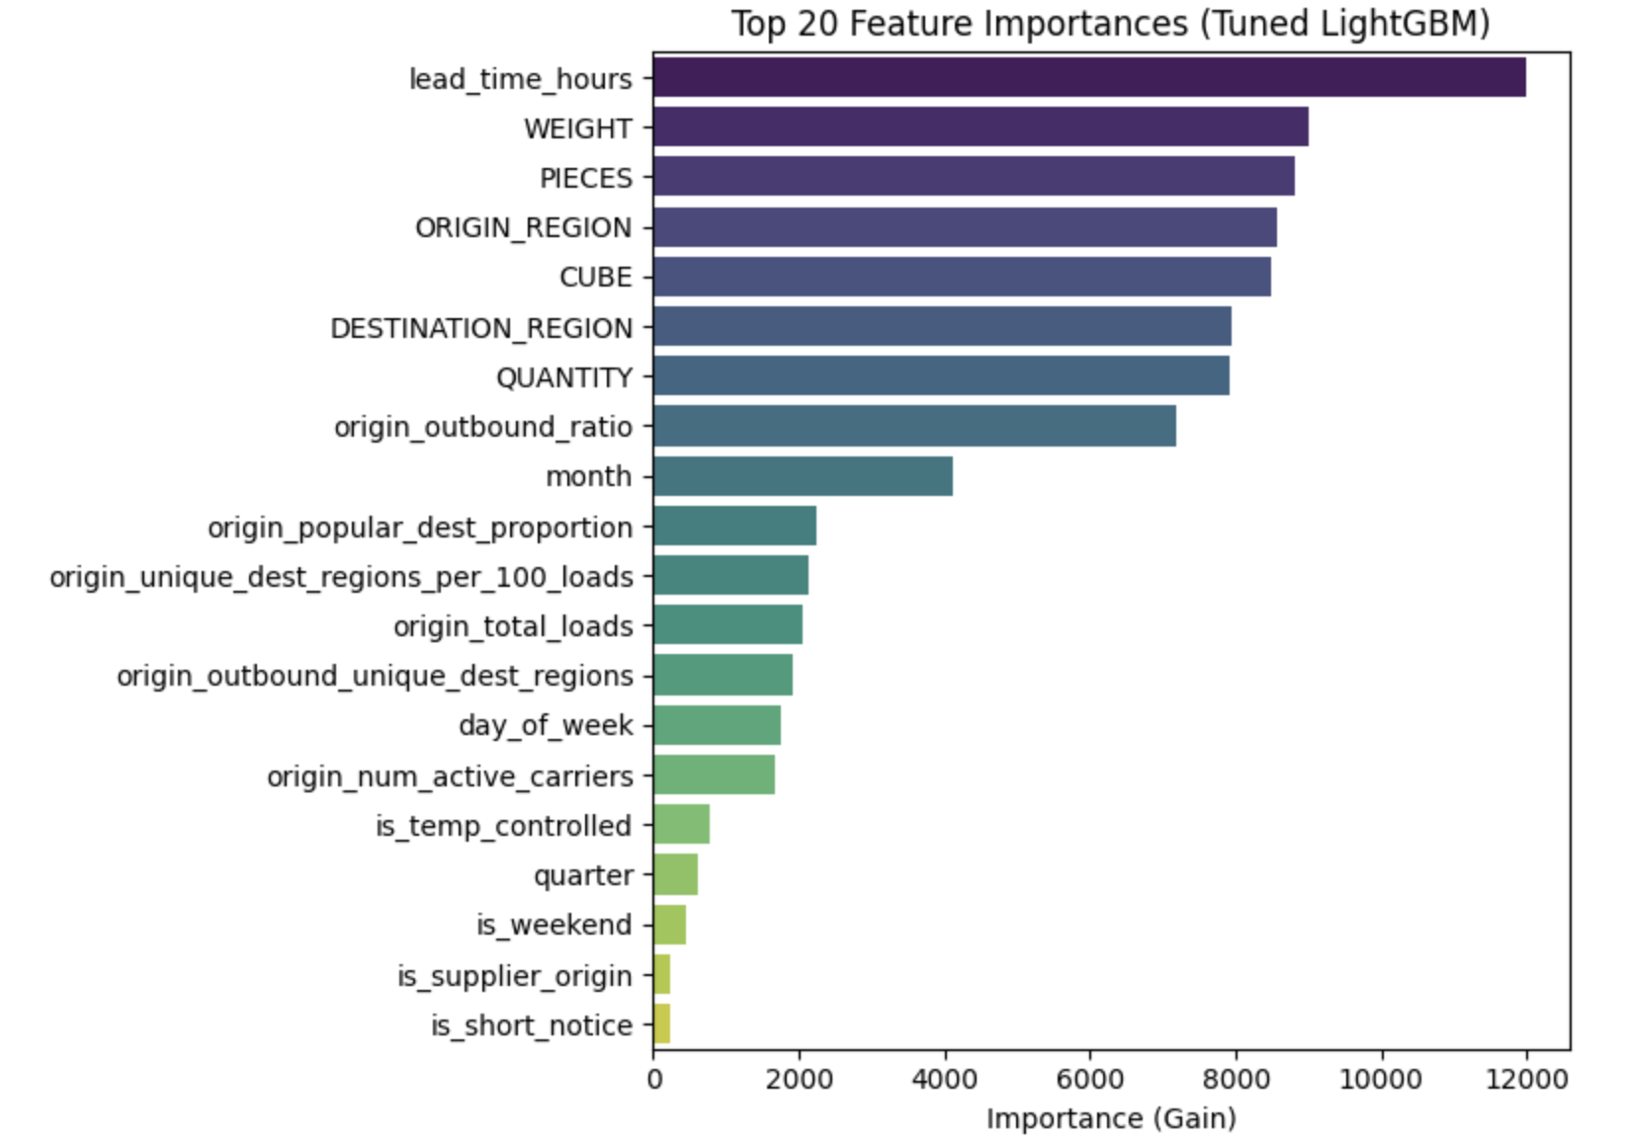

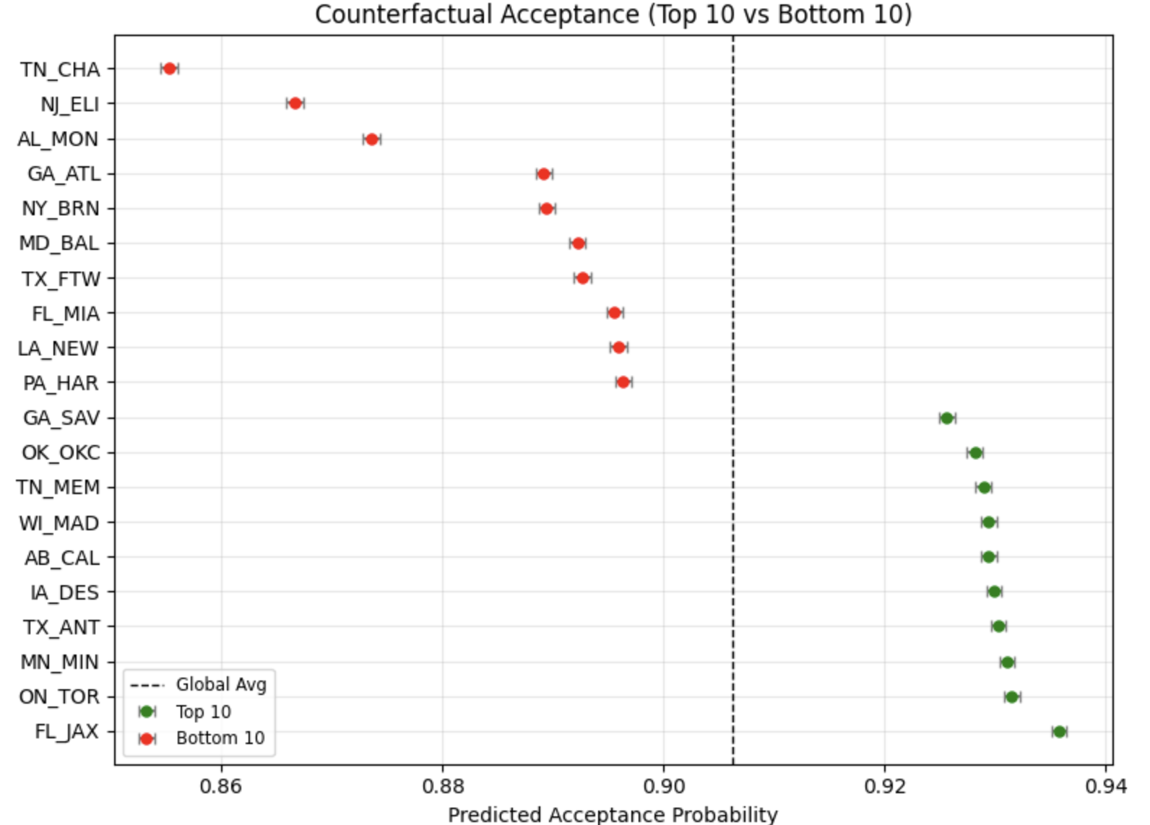

Discussion:
The Key Takeaways: The following markets are ranked among the top 10 markets when using both approaches. These are: Jacksonville (FL), Toronto (ON), Madison (WI), Memphis (TN), and Oklahoma (OK). This suggests that these markets are the most desirable markets to Armada carriers. Load lead time and the origin city’s inbound/outbound ratio appeared to significantly influence market desirability. Operational wise, these appear to be more important than pricing for carriers.

Future Research:
- Human verification of model results: Armada is more familiar with their network than we are, able to identify predictions that seem “off”.

- More detailed analysis of market desirability by more groupings: Include other data which might not have been available in this data set, like fuel price or weather information.

- The causal analysis pipeline can be easily adjusted, allowing it to investigate other variables of interest.

Appendix Section A: General EDA Results
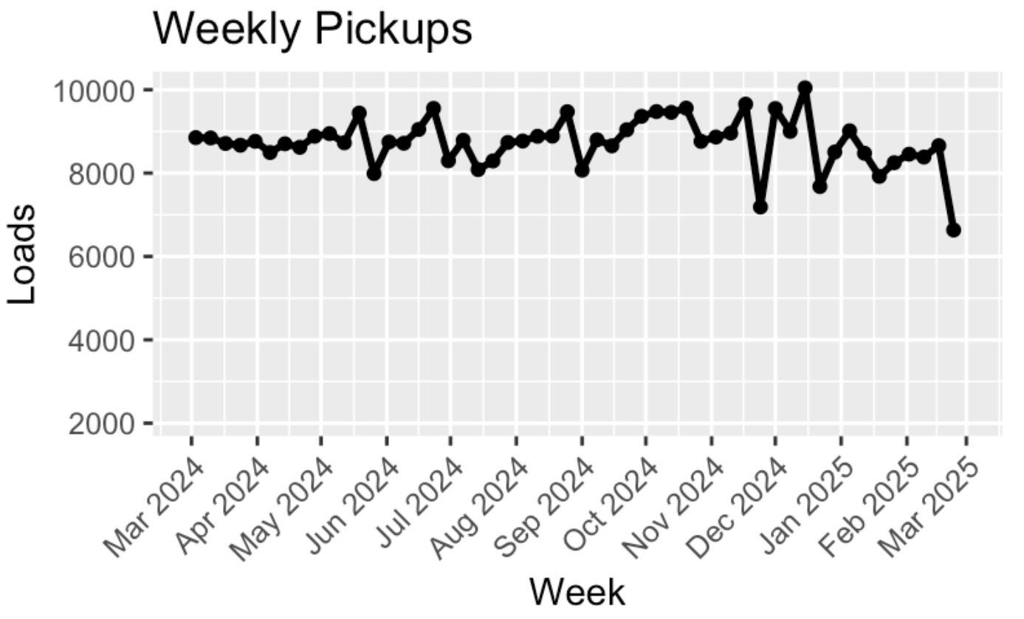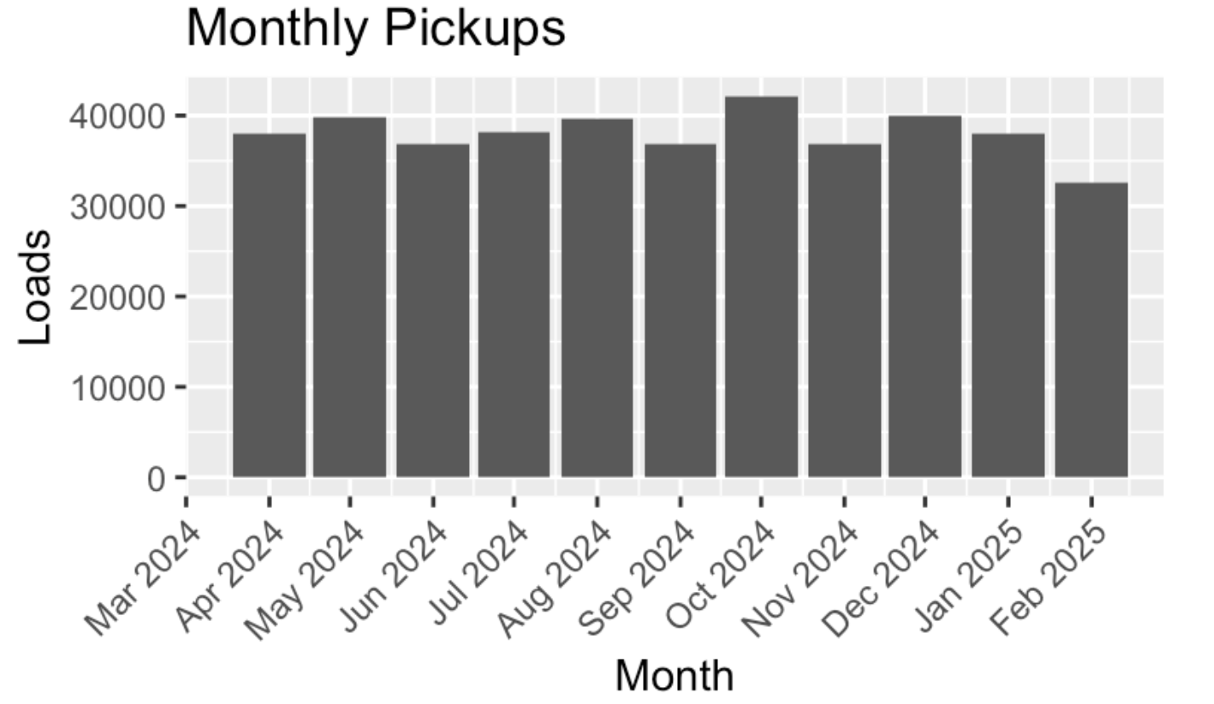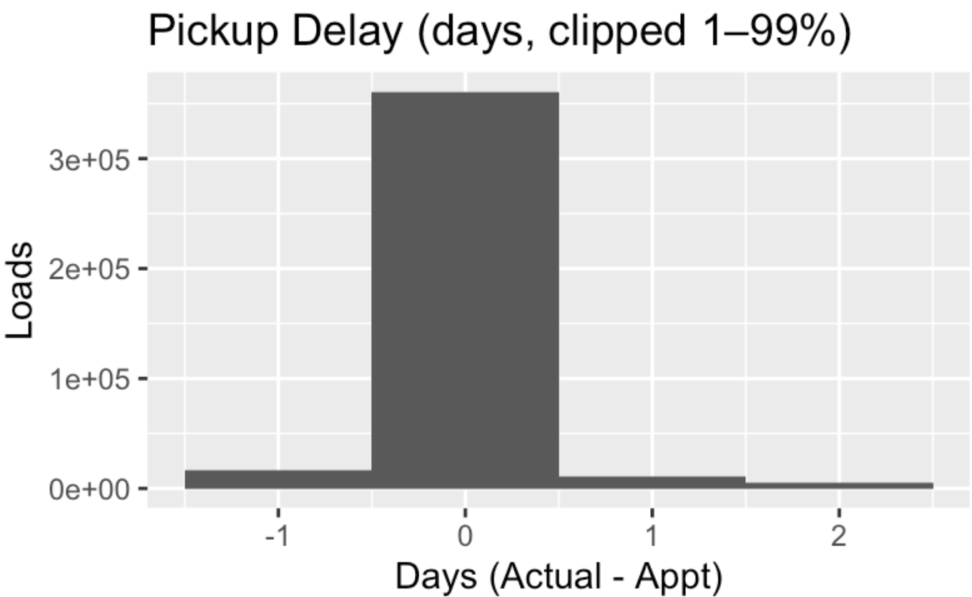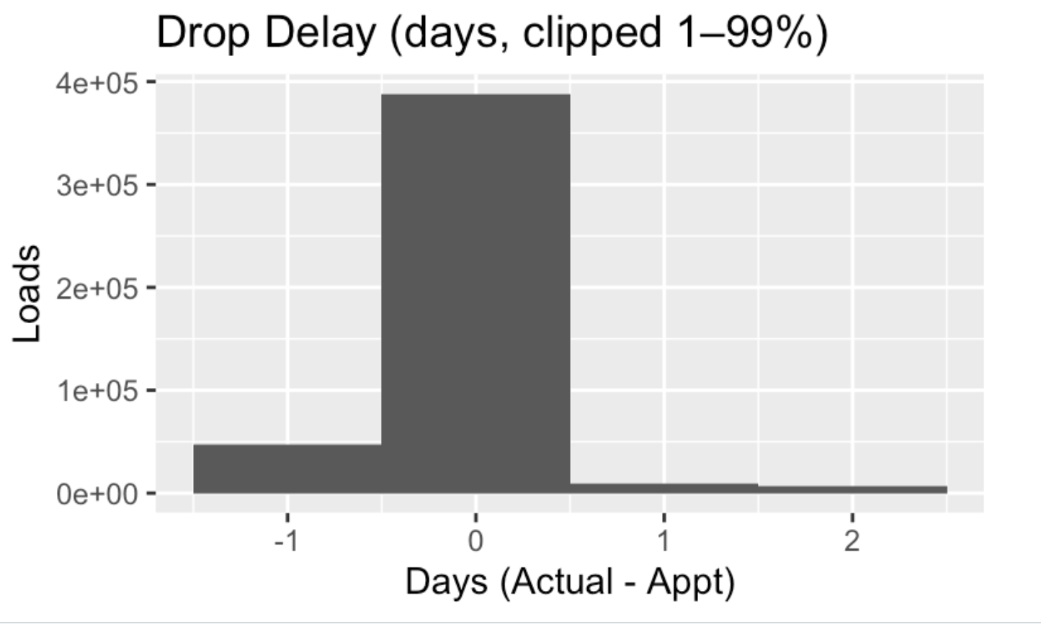
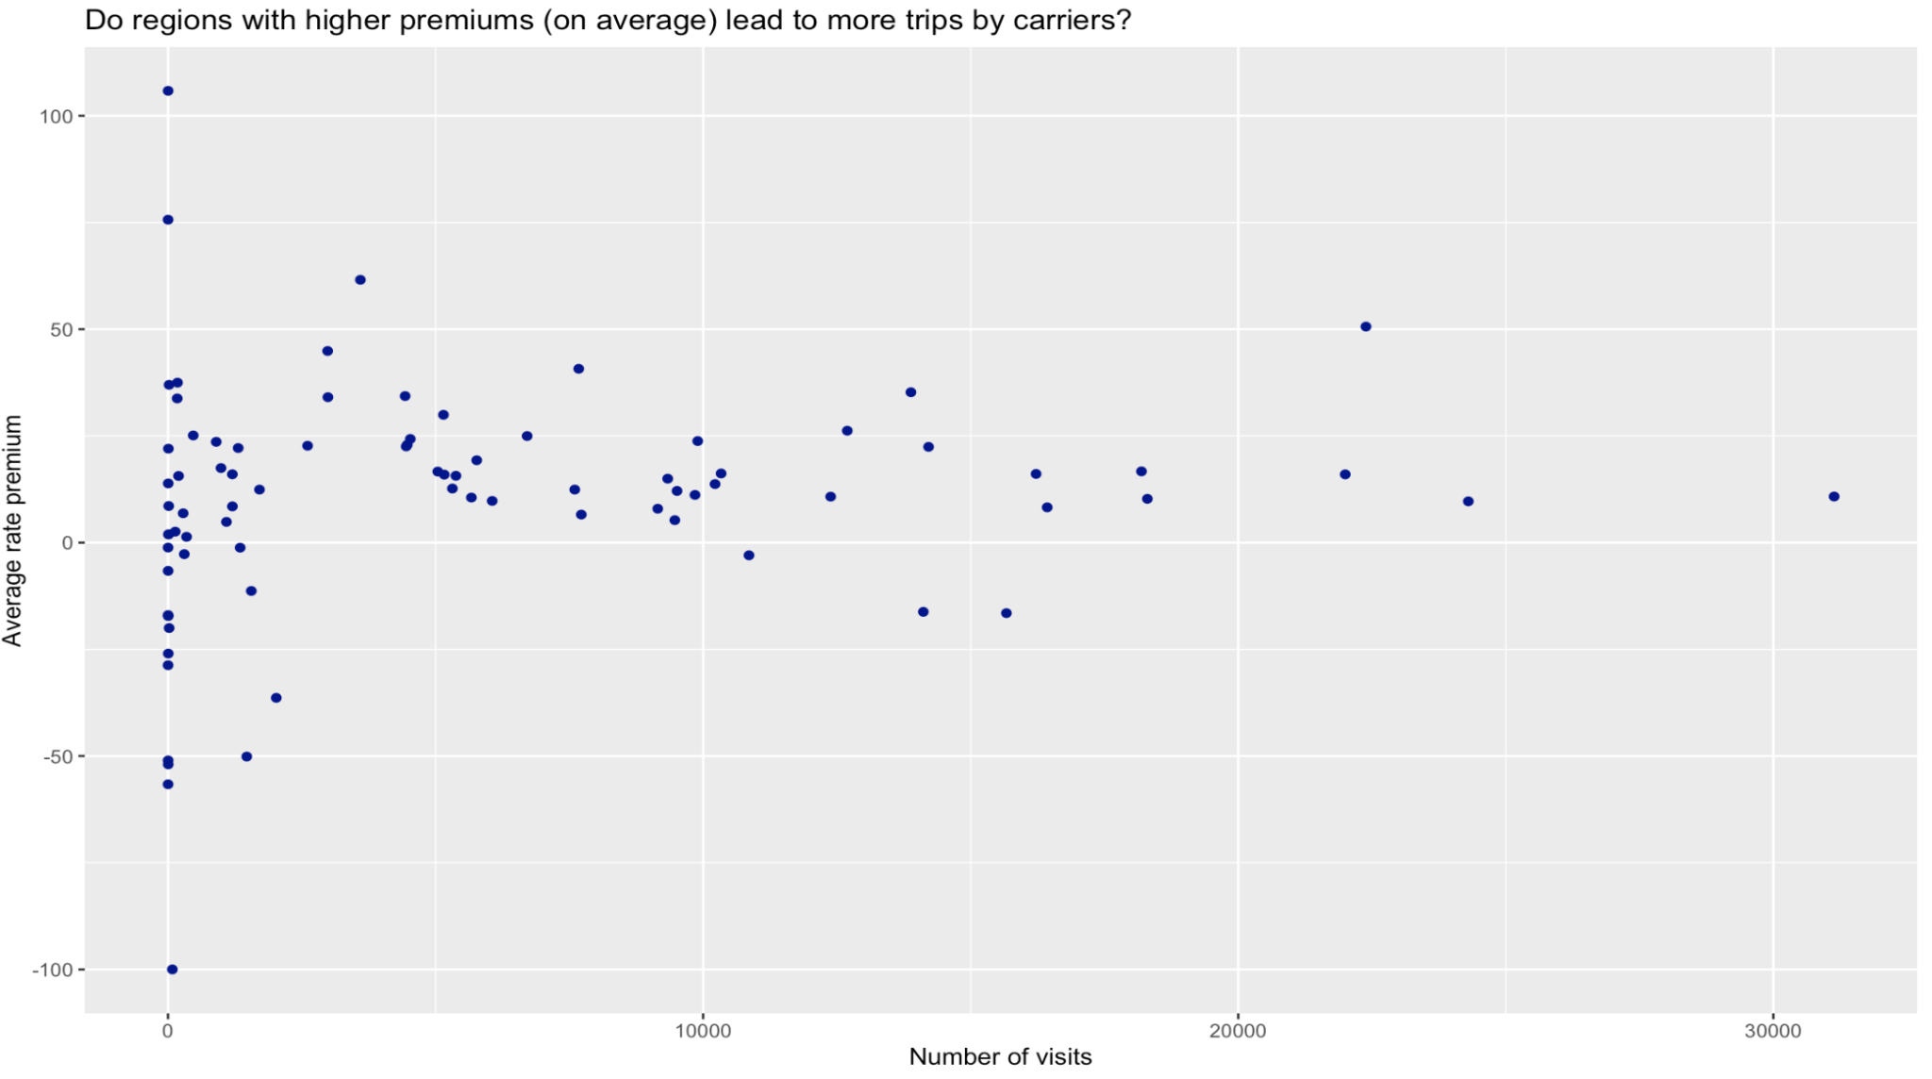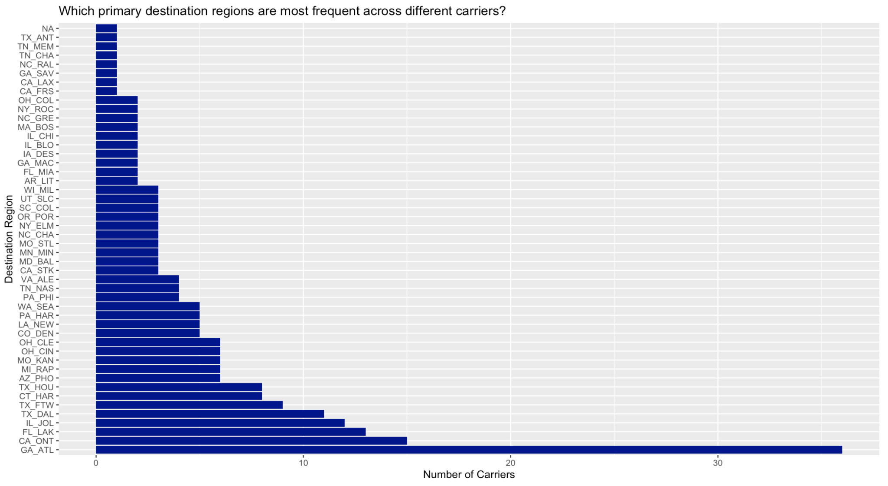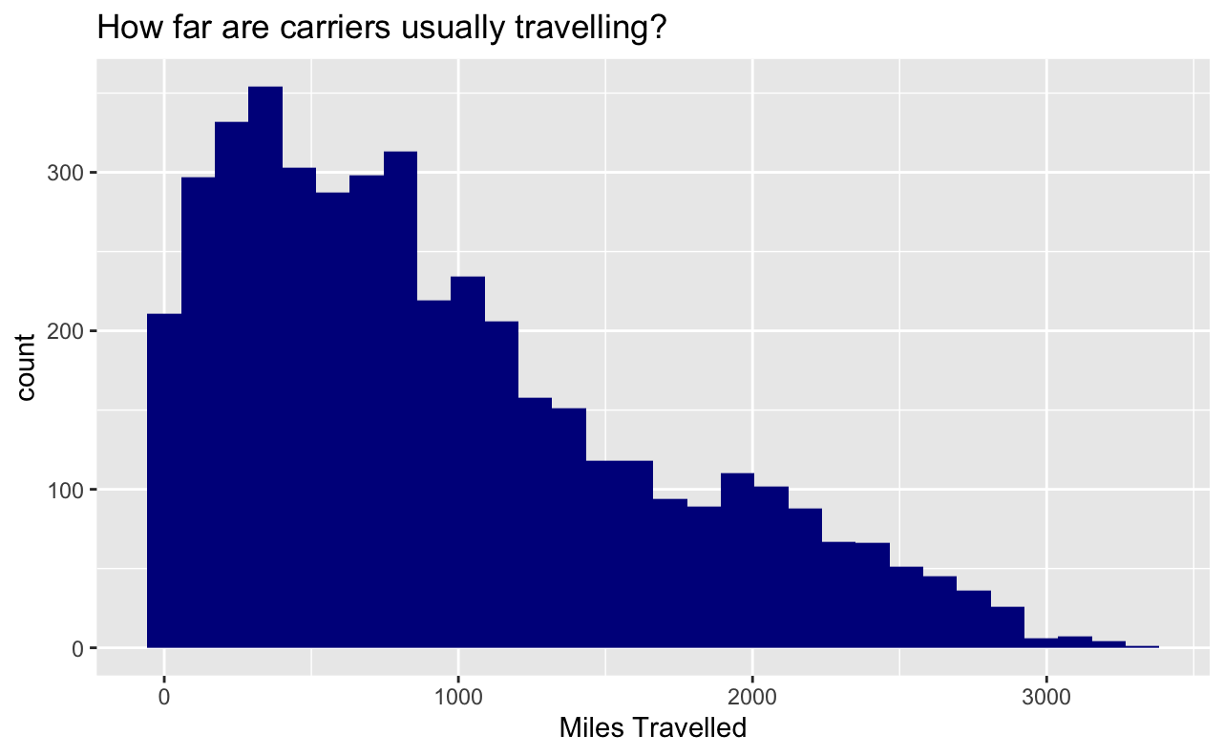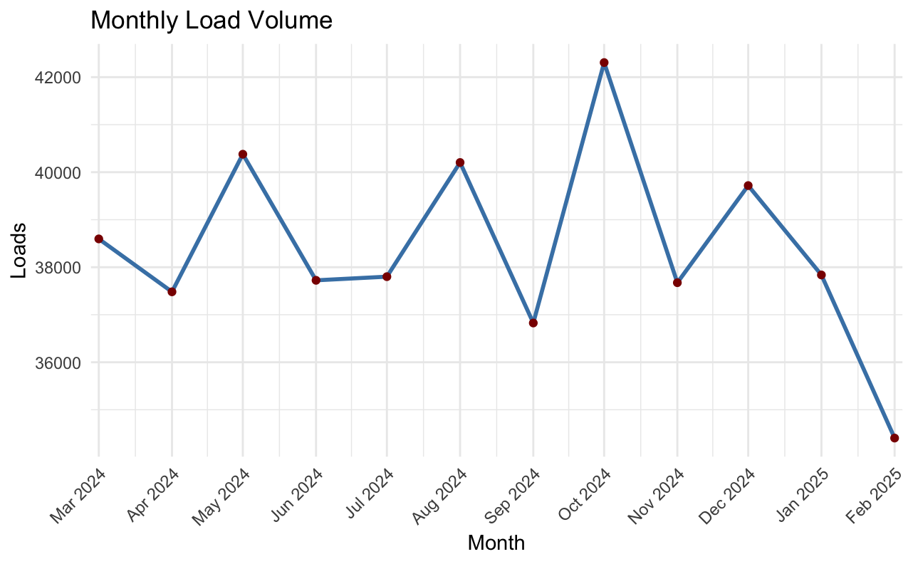
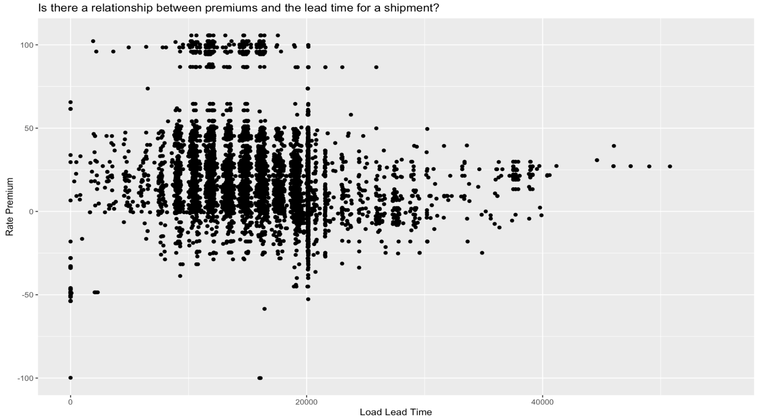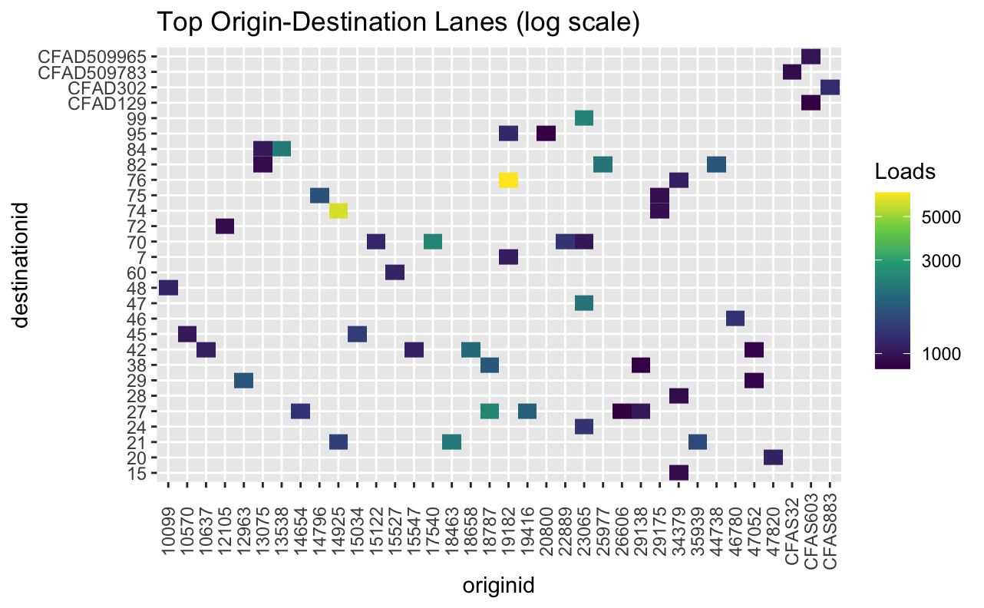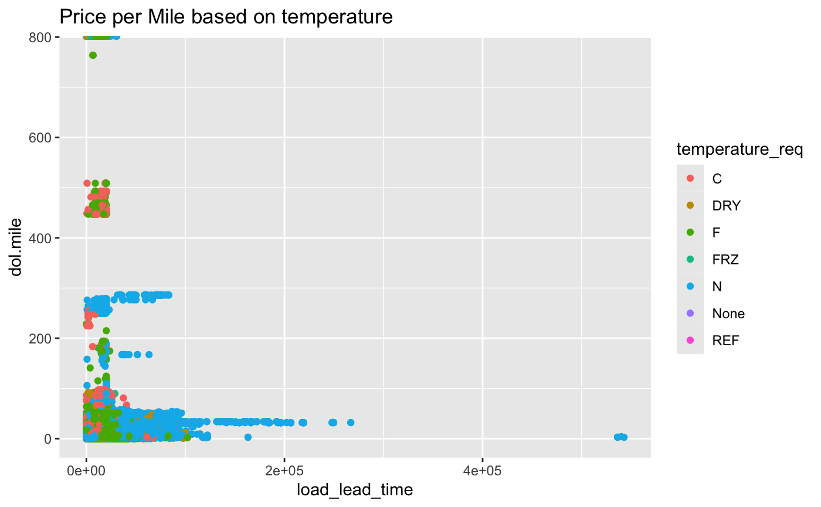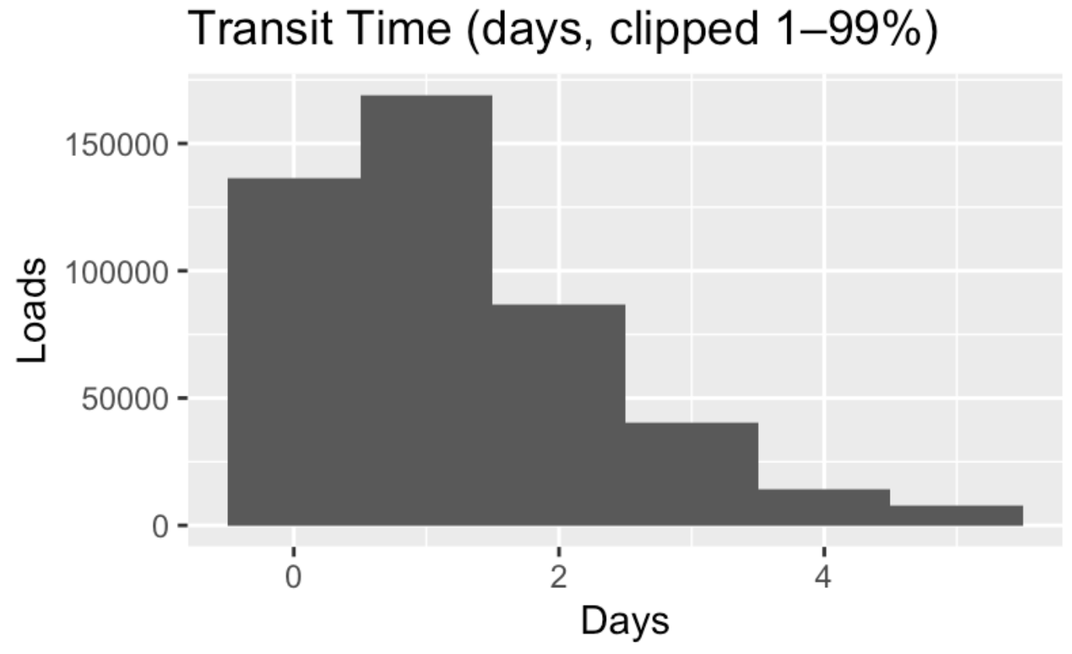
Section B: Primary Acceptance EDA Results

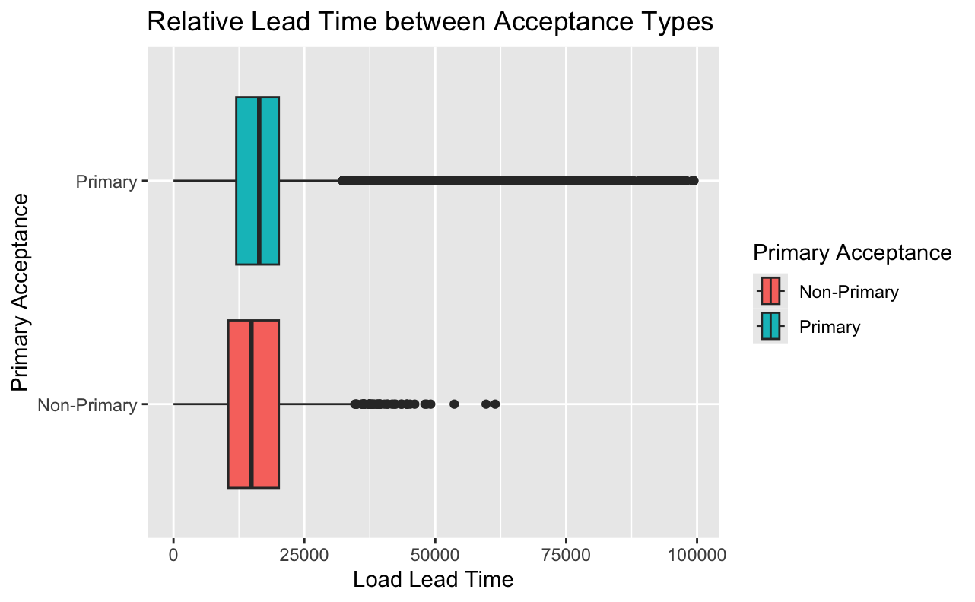
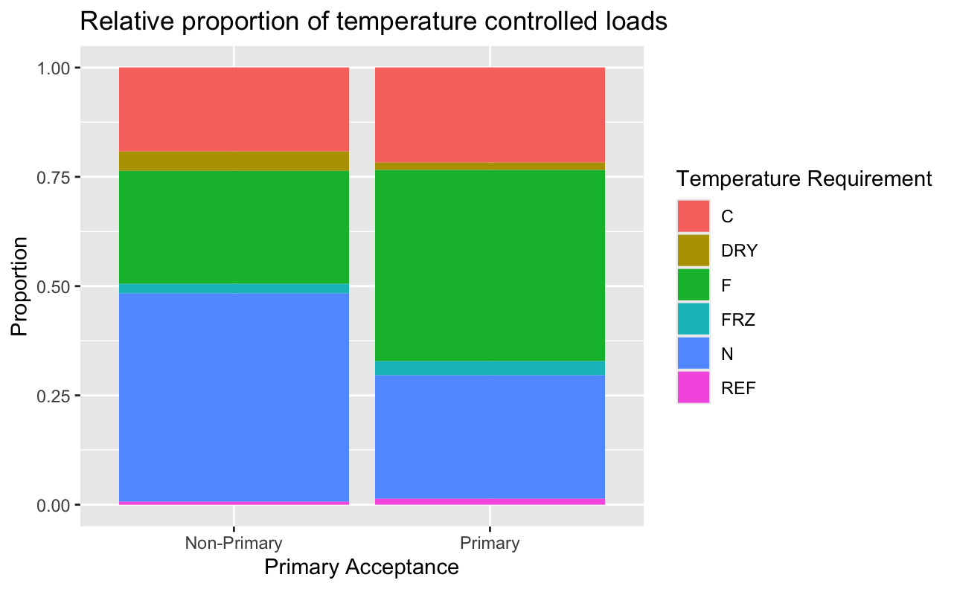
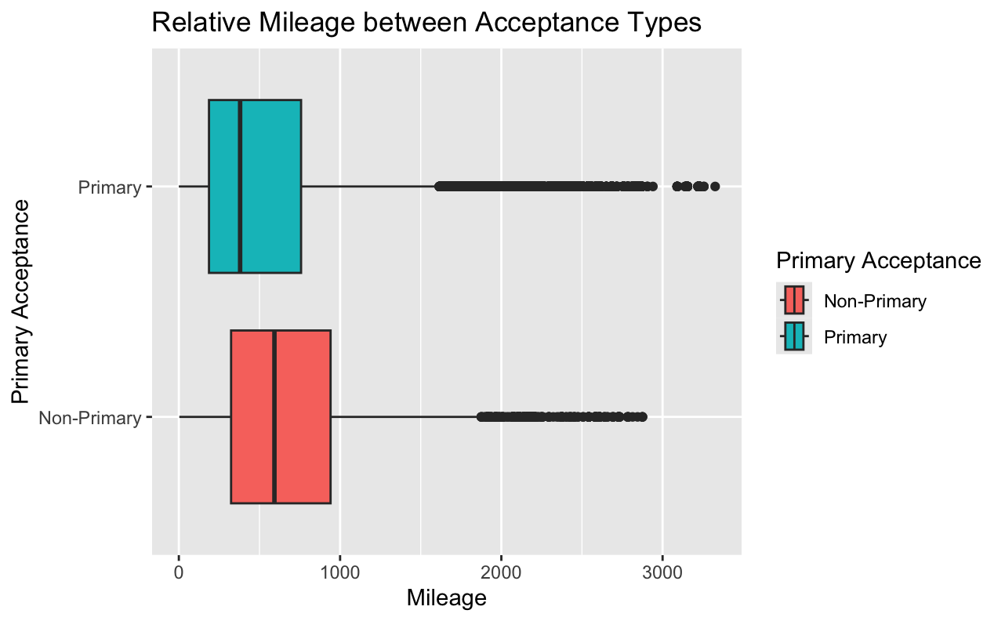
These two plots are not identical. They were constructed using two separate variables and verified multiple times. Both the spot rate and the mileage had very similar distributions.
